Ta teden ponavljamo besedišče iz enote Na kmetiji. Učenci iščejo pomen naslednjih besed ter potem v dvojicah preverjajo ali so pravilno naredili:
BARN (skedenj)
TRACTOR (traktor)
FARMER (kmet)
FIELD (polje)
HOUSE (hiša)
SCARECROW (strašilo)
SEED (seme)
BUCKET (vedro)
WHEAT (pšenica)
STABLE (hlev)
HAY (seno)
COW (krava)
HORSE (konj)
HEN (kokoš)
CHICKEN (piščanec)
PIG (pujs)
GOAT (koza)
SHEEP (ovca)
GOOSE (goska)
TURKEY (puran).
Če bo dovolj časa, poslušali, zapeli in zaplesali bomo pesem B-I-N-G-O https://consent/m?continue=%3Fcbrd%3D1&gl=&m=0&pc=yt&uxe=eomn&hl=sl&src=1
Naslednji teden učenci v besedilo iz obravnavane zgodbe o Jacku in čarobnem fižolu poiščejo in zapišejo manjkajoče besede.
Once upon a time there lived a poor widow and her son _________ . Jack went to the market. He sold a _______ and got five magic _______. The mother was very angry and threw the beans out of the _________. The next day there was a huge _________ . Jack climbed it and reached the kingdom in the ________ . There lived a ________ and his wife. The giant had a magic ______, who laid golden ________ and a magic ________ which played beautiful songs. Jack stole both and run down the beanstalk. The giant chased Jack but Jack quickly chopped the beanstalk. Jack and his ______ were now very rich.
Na projektorju bo prikazan slikopis:
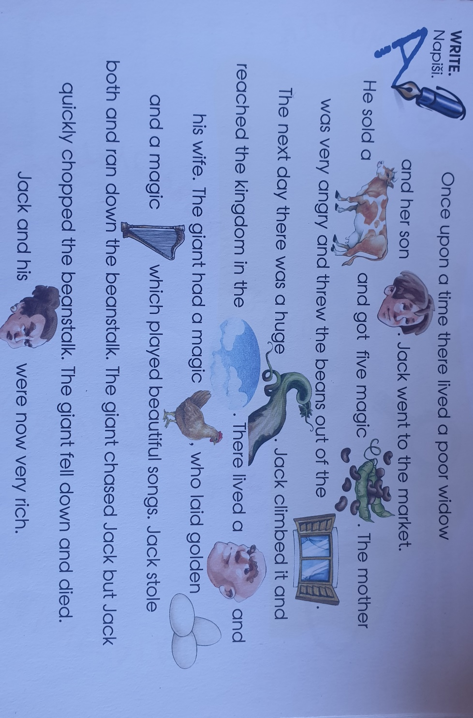

Za domačo nalogo prepišejo besedilo v zvezke.
Ponovimo pesem B-I-N-G-O.

